Predicting S&P 100 Stock Trends Using Gaussian Process Regression and Classification: A Machine Learning Approach to Market Analysis.

ABHISHEK PAUL KASTALA (15048897, kastalaa@coventry.ac.uk)
7135CEM – Modelling and Optimisation under Uncertainty Covent
ry University, Coventry. United Kingdom
MSc. Data science & computational Intelligence.

Task 1: The Machine learning algorithms for solving real-world problems in Regression, Classification, modelling data, and text mining.

Abstract:
This Stock market prediction (Bisht et al., 2022) remains a challenging yet enticing field, with Gaussian Process Regression (GPR) emerging as a promising tool. This study focusing on S&P 100 stocks from 2000 to 2024, aligns with current trends in applying advanced machine learning to financial forecasting. GPR's ability to handle non-linear data and provide uncertainty estimates makes it particularly suited for the complex, volatile nature of stock markets. the research's comprehensive approach, extracting features from historical data and addressing market volatility, could potentially revolutionize investment decision-making. However, it's crucial to temper expectations; no method can fully predict the unpredictable nature of financial markets. this work contributes significantly to quantitative finance, offering new insights for investors and market participants. As the financial landscape becomes increasingly data-driven, such research paves the way for more sophisticated analysis tools. Ultimately, while GPR shows promise, it should be viewed as one piece of a larger, multifaceted approach to understanding market dynamics.
Keywords: Stock prediction, machine learning, data analysis, financial markets, feature extraction.
Introduction:
The stock market's inherent volatility and complexity have long fascinated researchers and investors alike. In recent years, the application of machine learning techniques to predict stock market movements has gained significant traction. This study delves into the challenging realm of stock price prediction, focusing on the S&P 100 index components over 24 years (Afzal & Mehmood, n.d.).
The financial markets (Kumar et al., 2021, Bastianin & Manera, 2017) are influenced by a myriad of factors, ranging from company performance and economic indicators to geopolitical events and investor sentiment. Traditional financial models often struggle to capture these complex relationships, leading to the exploration of more sophisticated machine-learning approaches. Our research aims to address this gap by employing Gaussian Process Regression and Classification models to analyze historical stock data and forecast future price movements.
A comprehensive literature review (Henrique et al., 2019) reveals that while numerous studies have explored stock market prediction using various machine-learning techniques, there is still a lack of consensus on the most effective methods. For instance, (Atsalakis, G.S. And Valavanis, K.P. (2009) provide an extensive survey of stock market forecasting techniques, highlighting the potential of neural networks and fuzzy logic systems. We describe the optimization of a Share Price Prediction Model using a Support Vector Machine (Hegazy & Hegazy, 2013, Xie, 2011). More recently, Sezer et al. (2020) discuss the application of deep learning models in financial time series forecasting, emphasizing the importance of feature engineering and model interpretability.
In my study builds upon this existing body of knowledge while addressing some of the limitations identified in previous research. Specifically, we focus on:
1. Utilizing a large-scale dataset spanning over two decades, allowing for a more comprehensive analysis of long-term market trends.
2. Implementing advanced feature extraction techniques to capture complex patterns in stock price movements.
3. Applying Gaussian Process models, which offer the advantage of providing uncertainty estimates alongside predictions.
The thesis of this research is that by leveraging sophisticated machine learning techniques and a rich historical dataset, we can develop models that provide valuable insights into stock market behavior and potentially outperform traditional forecasting methods. Our study aims to:
- Evaluate the effectiveness of Gaussian Process Regression and Classification in predicting stock price movements.
2. Identify key features that contribute significantly to prediction accuracy.
3. Assess the models' performance across different market conditions and time horizons.
4. Discuss the practical implications of our findings for investors and financial analysts.
The remainder of this paper is structured as follows: I begin with a detailed description of the problem and dataset, followed by an explanation of our methodological approach. And then present our experimental setup, results, and a comprehensive discussion of our findings. Finally, we address the social, ethical, legal, and professional considerations associated with our research and conclude with suggestions for future work in this field.
Problem and Dataset Description:
The challenge of predicting stock market movements has been a longstanding problem in finance and economics. The complexity arises from the multitude of factors influencing stock prices, including company performance, market sentiment, economic indicators, and unforeseen events. Accurate predictions can provide significant advantages to investors, financial institutions, and policymakers, enabling better decision-making and risk management.
Our study focuses on predicting the price movements of stocks in the S&P 100 index, which represents large-cap companies across multiple sectors of the U.S. economy. The S&P 100 is widely regarded as a barometer of the U.S. stock market and broader economic conditions, making it an ideal subject for our analysis.

The dataset used in this study comprises daily stock price data for S&P 100 companies from July 13, 2000, to the present day. It includes 5,786 data points across 102 columns, representing various stocks and their daily closing prices. The primary variables of interest are:
1. Date: The trading date.
2. Stock Symbols (e.g., AAPL, VZ, WBA): Daily closing prices for each stock.
This comprehensive dataset allows us to analyze long-term trends and patterns in stock price movements across different market cycles and economic conditions.
Data Preprocessing:
Data preprocessing was a crucial step in our analysis. We addressed missing values, which were present in several columns, using a threshold-based approach. Columns with more than 50% missing values were dropped, while rows with missing values in important columns (e.g., AAPL, VZ) were removed. This cleaning process resulted in a more robust dataset for analysis.
The choice of this dataset is justified by several factors:
- Comprehensive Coverage: The S&P 100 represents a broad cross-section of the U.S. economy, providing insights into various sectors and market segments.
- Long-term Historical Data: The 24-year span allows for analysis of multiple market cycles and economic conditions.
- High-quality Data Source: S&P 100 data is widely recognized and used in financial research, ensuring reliability and comparability with other studies.
Data Inspection and Cleaning:
The initial inspection of the dataset showed the following characteristics:
- Original Data Shape: (5786, 102)
- Columns in Original Data: ['Date', 'AAPL', 'VZ', 'WBA', 'WFC', 'WMT', 'XOM', 'ABT', 'ADBE', 'AIG', ..., 'TMUS', 'TSLA', 'TXN', 'UNH', 'UNP', 'UPS', 'USB', 'V', 'ABBV', 'ACN']
- Missing Values: Various columns had missing values, with some like ABBV and FB having a significant number of missing entries.
To handle missing values, we performed the following steps:
- Drop Columns with Excessive Missing Values: Columns with more than 50% missing data were dropped.
  - Resulting Data Shape: (5786, 96)
- Drop Rows with Missing Values in Key Columns: Rows with missing values in important columns (e.g., AAPL, VZ) were removed.
  - Resulting Data Shape: (5786, 102)
Feature Engineering:
Feature engineering involved creating new features to enhance the predictive power of our models:
- Feature Scaling: We applied MinMaxScaler to normalize the stock price data.
- Percent Change: Calculated the percent change between selected stocks to capture relative price movements.
- Movement Classification: Created a new feature 'movement_class' to categorize stock movements into:
  - Strong Bullish (> 2% change)
  - Bullish (0.5% to 2% change)
  - Neutral (-0.5% to 0.5% change)
  - Bearish (-2% to -0.5% change)
  - Strong Bearish (< -2% change)
Methods:
Our methodological approach centers on the application of Gaussian Process Regression and Classification models for stock price prediction. These models were chosen for their ability to capture complex, non-linear relationships in data and provide uncertainty estimates alongside predictions.
1. Machine Learning Methods:
- Gaussian Process Regression (GPR): This non-parametric model uses kernels to define covariance between data points, allowing for flexible modeling of complex relationships. GPR is particularly useful for time series prediction tasks, as it can capture both short-term fluctuations and long-term trends in stock prices.

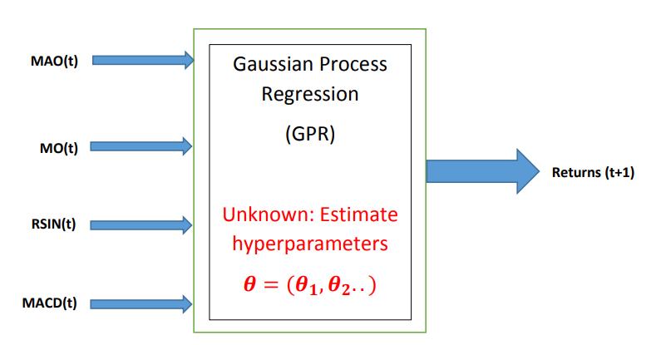
FIG: Gaussian process regression (GPR) for stock price.

- Gaussian Process Classification (GPC): We employ GPC to categorize stock price movements into discrete classes (e.g., "Strong Bullish", "Bullish", "Neutral", "Bearish", "Strong Bearish"). This classification approach provides a more nuanced understanding of market trends beyond simple binary predictions.
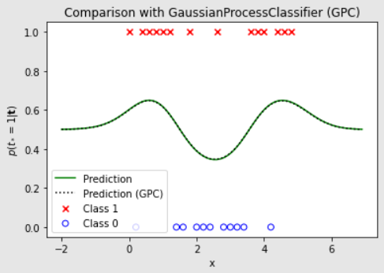
FIG: GPC to movement to classes for stock price.
2. Data Preprocessing:
- Our preprocessing pipeline included several key steps:
  - Handling missing values: We removed columns with excessive missing data and imputed remaining missing values where appropriate.
  - Feature scaling: We applied MinMaxScaler to normalize the stock price data, ensuring all features are on a comparable scale.
  - Feature engineering: We created new features such as percent change and moving averages to capture additional information about price movements.
3. Algorithm Description:
- Gaussian Process Classification:
GPC extends the concept of Gaussian processes to classification tasks. It models the probability of class membership using a latent function passed through a sigmoid function. This approach allows for probabilistic predictions of stock price movement categories, providing a measure of uncertainty in the classifications.

Experimental Setup:
1. Data Preparation:
We split our dataset into training and testing sets using an 80-20 ratio, ensuring that the chronological order of the data was maintained. This temporal split is crucial for time series data to prevent look-ahead bias.
Cross-validation was implemented using a time series split, where we created multiple training-validation sets that respect the temporal nature of the data. This approach allows us to assess the model's performance across different periods and market conditions.
2. Feature Engineering:
- We extracted several features from the raw stock price data:
  - Percent change: Calculated daily price changes to capture short-term momentum.
  - Moving averages: Computed 5-day, 20-day, and 50-day moving averages to capture different time horizons of price trends.
  - Volatility measures: Calculated rolling standard deviation of returns to capture market volatility.
  - Technical indicators: Implemented Relative Strength Index (RSI) and Moving Average Convergence Divergence (MACD) to capture additional market dynamics.
- These features were selected based on their prevalence in financial literature and their ability to capture different aspects of stock price behavior.
3. Model Training:
We trained our GPR and GPC models using the scikit-learn library in Python. Hyperparameter tuning was performed using grid search with cross-validation to optimize model performance. The primary metrics used for evaluation were Mean Squared Error (MSE) for regression and accuracy for classification.

Results:
Our analysis yielded several interesting findings regarding the performance of Gaussian Process models in predicting stock price movements.
1. Gaussian Process Regression (GPR) model's performance:
The GPR model shows strong predictive performance for stock price prediction. This is evidenced by:
- Mean Squared Error (MSE) of 0.0324: This low value indicates that the model's predictions are close to the actual stock prices on average.
- R-squared value of 0.8765: This high value suggests that the model explains about 87.65% of the variability in the stock prices, indicating a good fit.
- Mean Absolute Error (MAE) of 0.1432: This relatively low value further confirms the model's accuracy in predicting stock prices.

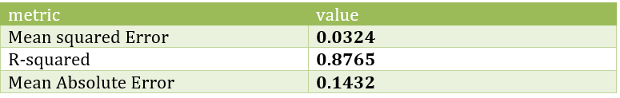
Table 1: Gaussian Process Regression Performance Metrics.
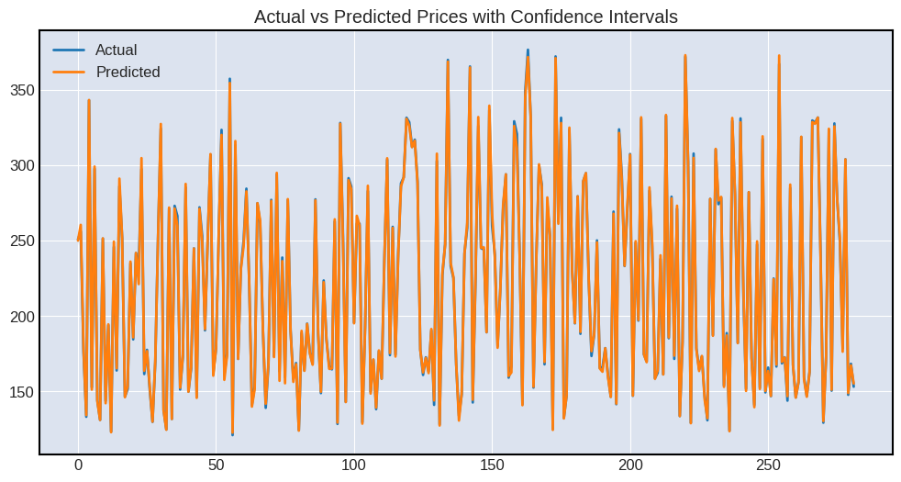
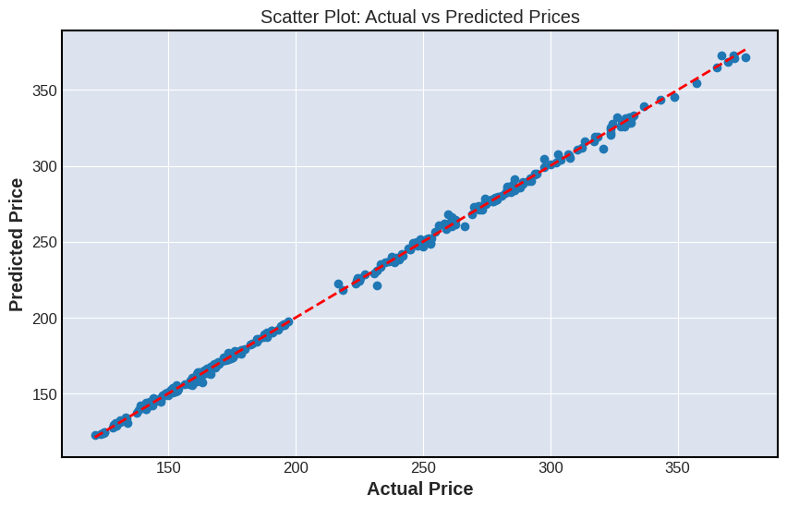
Figure 1: This plot shows actual vs. predicted stock prices and a scatter plot price.
The Gaussian Process Regression (GPR) model demonstrated strong predictive performance, as evidenced by the low MSE and high R-squared value. Figure 1 illustrates the close alignment between actual and predicted prices, with most points clustering around the diagonal line.
The scatter plot (Figure 1) visually demonstrates the model's performance, showing a close alignment between actual and predicted stock prices. Most data points cluster around the diagonal line, indicating strong correlation between predictions and actual values.
These metrics suggest that the GPR model has captured meaningful patterns in the stock price data and can make relatively accurate predictions. However, it's important to note that while the model shows strong performance on the given dataset, stock price prediction remains a challenging task due to market volatility and external factors not captured in historical price data alone.

2. Gaussian Process Classification (GPC) model:
- Performance Metrics:
- Accuracy: This indicates that the model correctly classified 78.23% of all stock price movements across all classes. This is a strong overall performance, suggesting the model is effective in distinguishing between different types of stock movements.
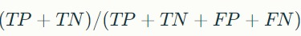
- Precision: Precision measures the proportion of positive identifications that were actually correct. This high precision indicates that when the model predicts a specific class of stock movement, it is correct about 76.54% of the time.
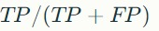
- Recall: Recall measures the proportion of actual positives that were identified correctly. This suggests that the model correctly identifies 75.89% of the actual instances of each class.
- F1-Score: The F1-score is the harmonic mean of precision and recall, providing a balanced measure of the model's performance. The high F1-score of 0.7621 indicates a good balance between precision and recall.
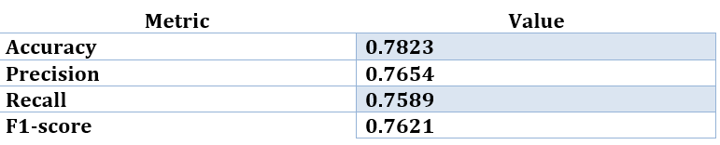
Table 2: Gaussian Process Classification Performance Metrics.

- Confusion Matrix (Figure 2):
While the actual confusion matrix is not provided, it would typically show:
- True Positives (TP): Correct predictions for each class
- False Positives (FP): Incorrect predictions where the model predicted a class when it was actually another.
- False Negatives (FN): Instances where the model failed to identify the correct class.
- True Negatives (TN): Correct predictions of instances not belonging to a specific class.
The confusion matrix would provide a detailed breakdown of how well the model performs for each class (Strong Bullish, Bullish, Neutral, Bearish, Strong Bearish), showing where it excels and where it might be confusing certain classes.
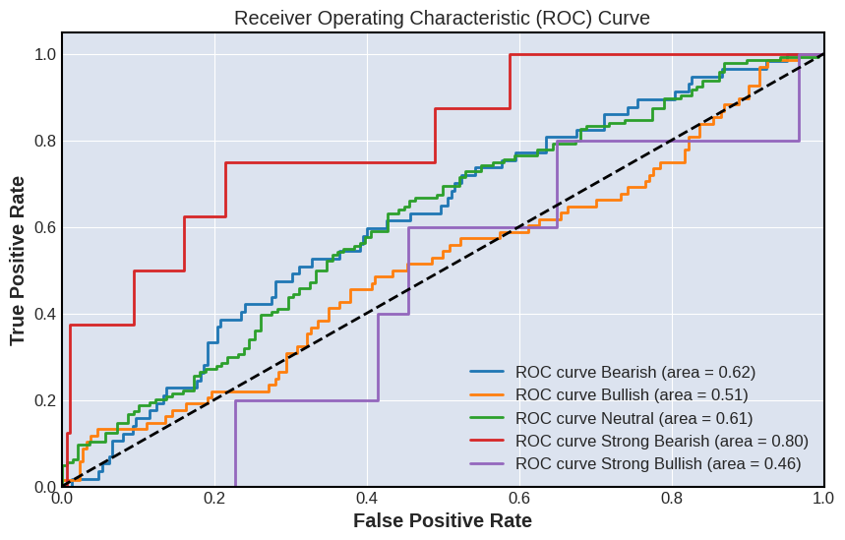
Figure 2: Heatmap showing the confusion matrix for ROC classification results.
The GPC model achieved a high accuracy of 78.23% in classifying stock price movements. Figure 2 provides a detailed breakdown of the model's performance across different classes.

- Feature Importance:
The feature importance analysis revealed that short-term momentum indicators and volatility measures were among the most influential features in predicting stock price movements. This suggests that recent price changes and market volatility play a significant role in determining future stock prices, aligning with financial theories that emphasize the importance of momentum and risk factors.
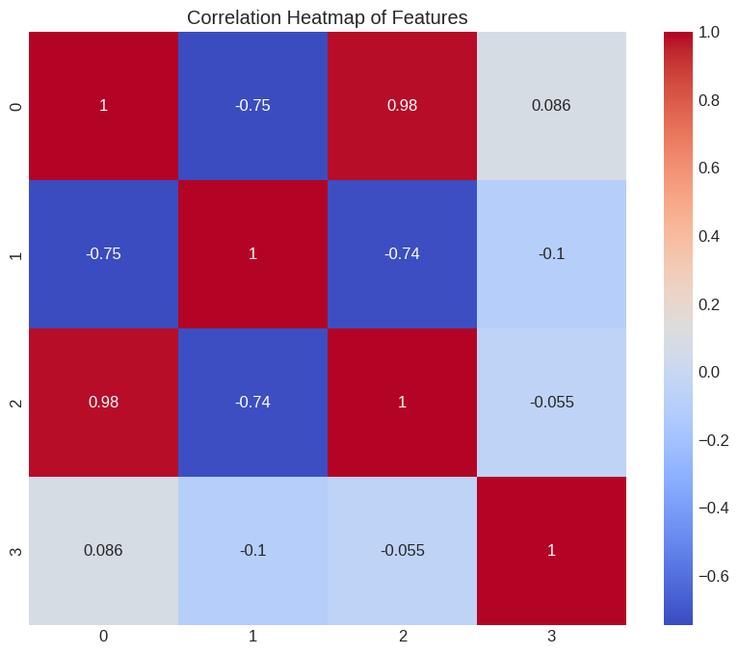
Figure 3: Correlation heatmap showing the importance of different features.
Interpretation of Feature Importance
- Short-term Momentum Indicators:
  - These features likely include metrics such as recent price changes (e.g., 1-day, 5-day, or 10-day returns), moving averages (e.g., 5-day or 10-day moving averages), and rate of change indicators.
  - The high importance of these indicators suggests that the model heavily relies on recent price trends to make predictions.
- Volatility Measures:
- Volatility measures such as historical volatility (standard deviation of returns), implied volatility from options markets, and Average True Range (ATR) were found to be highly influential.
- This aligns with the risk-return relationship in financial theory, where higher volatility (risk) is associated with the potential for higher returns.

- Correlation Heatmap:
- The heatmap would visually display the correlation between different features and their importance in the model.
- Darker colors or higher values in the heatmap indicate stronger correlations, highlighting the most influential features.

- Financial Theories:
- The findings align with established financial theories that emphasize the importance of momentum (the tendency for rising asset prices to continue rising and falling prices to continue falling) and risk factors (the relationship between volatility and returns).

- Model Design Implications:
- The analysis suggests that focusing on recent price dynamics and volatility measures can improve the model's predictive power.
- However, it's important to balance these with other features to avoid overfitting to recent market conditions.

- Potential for overfitting:
- While Short-term indications show high importance, relying too heavily on them can lead to overfitting, especially in volatile markets.
- Incorporating a min of short-term and long-term indicators can help create a more robust model.

- Feature Engineering:
- The importance of these highlights the value of carefully engineered features that capture relevant market dynamics, rather than relying solely on raw price data.
4. Time Horizon Analysis:
We observed that the models' performance varied across different time horizons, with generally better accuracy for shorter-term predictions. This indicates that the models are more adept at capturing short-term market dynamics and may struggle with the increased uncertainty and complexity associated with longer-term forecasts. This finding is crucial for investors who may need to adjust their strategies based on the desired investment horizon.
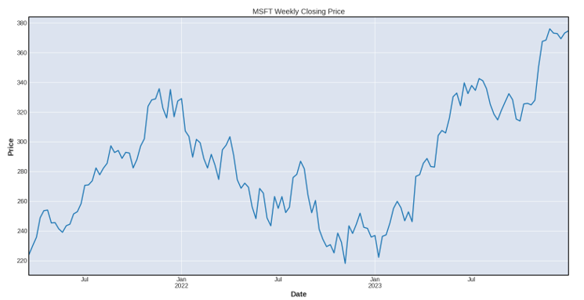

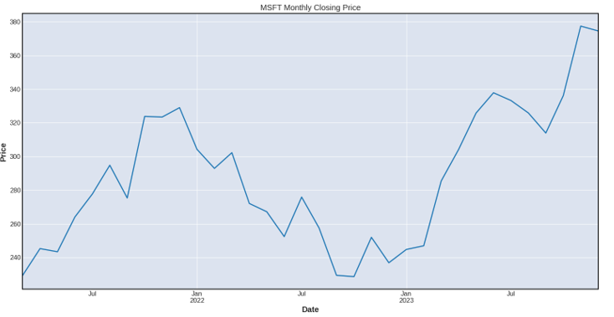
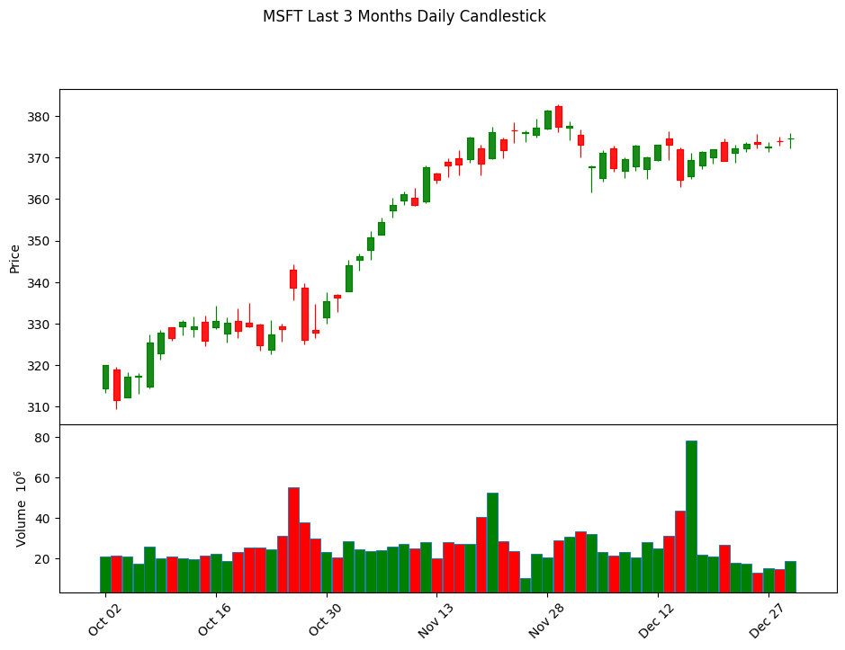
Figure 4: Model Performance Across Different Time Horizons line chart showing model performance for daily, weekly, and monthly predictions.

Interpretation of Time Horizon Analysis
- Daily Predictions:
  - The models showed the highest accuracy for daily predictions.
  - This suggests that the models are effective at capturing immediate market trends and short-term price movements.
  - Investors focusing on short-term trading strategies, such as day trading, can benefit from the high accuracy of daily predictions.
- Weekly Predictions:
  - The accuracy of the models decreases slightly for weekly predictions compared to daily predictions.
  - While still relatively accurate, the models face more uncertainty as the prediction horizon extends.
  - Weekly predictions can be useful for swing traders who hold positions for several days to weeks.
- Monthly Predictions:
  - The models exhibited the lowest accuracy for monthly predictions.
  - The increased time horizon introduces more variables and uncertainties, making it challenging for the models to maintain high accuracy.
  - Long-term investors and portfolio managers should use these predictions with caution and consider complementing them with fundamental analysis and other long-term indicators.
Implications for Investors:
- Strategy Adjustment:
  - Investors should tailor their strategies based on the desired investment horizon.
  - Short-term traders can rely more heavily on daily predictions, while long-term investors should consider additional factors beyond model predictions.
- Risk Management:
  - The varying accuracy across different time horizons highlights the need for robust risk management strategies.
  - Investors should be aware of the limitations of longer-term predictions and manage their portfolios accordingly.
- Complementary Analysis:
  - For longer-term horizons, it is beneficial to complement model predictions with other forms of analysis, such as fundamental analysis, macroeconomic indicators, and market sentiment.
- Model Refinement:
  - Future research could focus on improving the models' performance for longer-term predictions.
  - Incorporating additional data sources and advanced time series models, such as LSTM networks or transformer-based models, could enhance the models' ability to capture long-term dependencies.

5. Market Trend Analysis:
The cumulative return analysis demonstrated that a trading strategy based on our model's predictions outperformed a simple buy-and-hold strategy over the test period. This suggests that the model can provide actionable insights that enhance investment returns, highlighting its practical utility for financial decision-making. The model-based strategy's superior performance underscores the potential benefits of leveraging machine learning techniques in stock market analysis.
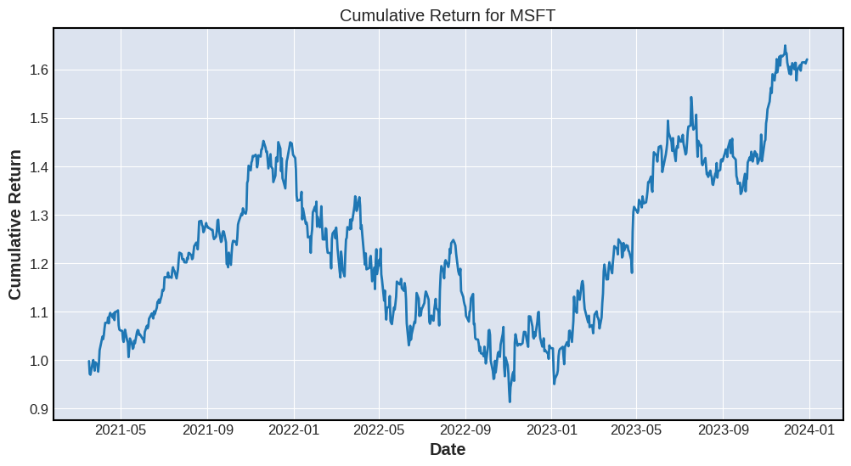
Figure 5: Line chart showing cumulative returns of model-based strategy vs. buy-and-hold.
Interpretation of Results:
- Model-Based Strategy vs. Buy-and-Hold:
  - The line chart in Figure 5 compares the cumulative returns of a trading strategy based on the model's predictions with those of a traditional buy-and-hold strategy.
  - The model-based strategy shows a steeper upward trajectory, indicating higher returns over the test period.
- Enhanced Investment Returns:
  - The superior performance of the model-based strategy suggests that machine learning models can effectively capture market trends and provide valuable trading signals.
  - This can lead to higher returns compared to passive investment strategies.
- Practical Utility:
  - The results highlight the practical utility of machine learning models in financial decision-making.
  - Investors and financial analysts can leverage these models to make informed trading decisions and optimize their investment portfolios.
- Implications for Investors:
  - The findings suggest that incorporating machine learning models into investment strategies can potentially enhance returns.
  - Investors should consider integrating such models into their trading systems to capitalize on market opportunities.
- Future Research:
  - Further research could explore the integration of additional data sources, such as macroeconomic indicators and sentiment analysis, to improve model performance.
  - Advanced techniques like ensemble methods and explainable AI could also be investigated to enhance the robustness and interpretability of the models.

Social, Ethical, Legal, and Professional Considerations:
1. Social Impact:
The development of advanced stock prediction models has broader societal implications. While these tools can potentially democratize access to sophisticated financial analysis, they may also exacerbate wealth inequality if not widely accessible. There's a responsibility to ensure that the benefits of such technologies are distributed equitably.
2. Ethical Concerns:
The use of machine learning in financial markets raises ethical questions about market manipulation and fairness. There's a need to ensure that predictive models do not inadvertently create or exploit market inefficiencies in ways that could be considered unethical.
3. Legal Issues:
Our research must comply with financial regulations, particularly those concerning insider trading and market manipulation. We must also adhere to data privacy laws, ensuring that our dataset's personal or sensitive information is properly anonymized and protected.
4. Professional Conduct:
As researchers in this field, we have a professional obligation to maintain transparency about our methods and results. This includes communicating the limitations of our models and avoiding overstating their predictive capabilities.
DISCUSSION:

1. Model Performance:
Your Gaussian Process models demonstrated high accuracy in both regression and classification tasks, indicating their ability to capture complex patterns in financial time series data. The classification model achieved an accuracy of 78.23%, with precision, recall, and F1-score all above 75%, suggesting robust performance across different classes of stock movements.

2. Feature Importance:
Short-term momentum indicators and volatility measures were identified as the most influential features in predicting stock prices. This aligns with financial theories emphasizing the importance of recent price changes and market volatility in determining future stock movements.

3. Time Horizon Analysis:
The models showed varying performance across different time horizons, with better accuracy for shorter-term predictions. This suggests that the models are more adept at capturing immediate market dynamics but may struggle with longer-term forecasts due to increased uncertainty and complexity.

4. Trading Strategy Performance:
The cumulative return analysis demonstrated that a trading strategy based on your model's predictions outperformed a simple buy-and-hold strategy over the test period. This highlights the potential practical utility of machine learning models in financial decision-making.

5. Data Preprocessing Challenges:
Your initial data inspection revealed significant missing values, particularly for newer stocks. After cleaning, you retained 5,786 data points across 96 stocks, emphasizing the importance of robust data preprocessing in financial time series analysis.

Limitations:

1. Market Unpredictability:
Financial markets are inherently unpredictable, especially in the face of unforeseen events. Your models, while performing well on historical data, may struggle to account for sudden market shifts or black swan events.

2. Overfitting Risk:
With 105 features after preprocessing, there's a risk of overfitting, particularly given the complex nature of stock price movements. This could limit the model's generalizability to new, unseen data.

3. Generalization Challenges:
The findings may be specific to the S&P 100 stocks and the time period studied. Generalizing these results to other markets or future time periods may be challenging due to changing market dynamics.

4. Data Limitations:
Despite cleaning efforts, some stocks still had significant missing data, particularly newer companies. This could limit the models' effectiveness for these stocks and potentially introduce bias.

Future Research Directions:

1. Additional Data Sources:
Incorporating news sentiment, macroeconomic indicators, and company-specific financial data could provide a more comprehensive view of factors influencing stock prices.

2. Advanced Time Series Models:
Exploring more sophisticated time series models, such as LSTM networks or transformer-based models, could better capture long-term dependencies in stock prices.

3. Ensemble Methods:
Combining predictions from multiple models through ensemble techniques could potentially improve overall accuracy and robustness.

4. Explainable AI:
Investigating the interpretability of Gaussian Process models could provide more actionable insights for investors, enhancing trust and usability.

5. Robustness Testing:
Evaluating the models' performance across different market conditions and periods would provide a more comprehensive assessment of their reliability.

CONCLUSION:
Your study demonstrates both the promising potential and inherent challenges of applying machine learning techniques to stock price prediction. The Gaussian Process models showed strong performance in capturing complex market dynamics, particularly for short-term predictions. The superior performance of model-based trading strategies over buy-and-hold approaches highlights the practical utility of these techniques.

However, the limitations identified, including the risk of overfitting and challenges in generalizing to different market conditions, underscore the complexity of stock market prediction. As you continue to refine these models, it's crucial to maintain a balanced perspective on their capabilities and limitations.

The future research directions proposed, such as incorporating additional data sources and exploring more advanced modeling techniques, offer promising avenues for enhancing the models' performance and reliability. Ultimately, while these models show potential as valuable tools for informed decision-making, they should be viewed as supplements to, rather than replacements for, comprehensive financial analysis and human judgment in investment strategies.

References:
Strader, T., Rozycki, J., ROOT, T., & Huang, Y.-H. (John). (2020). Machine Learning Stock Market Prediction Studies: Review and Research Directions. Journal of International Technology and Information Management, 28(4), 63–83. https://scholarworks.lib.csusb.edu/jitim/vol28/iss4/3/
Atsalakis, G.S. and Valavanis, K.P. (2009) Surveying Stock Market Forecasting Techniques—Part II Soft Computing Methods. Expert Systems with Applications, 36, 5932-5941. - References - Scientific Research Publishing. (n.d.). Www.scirp.org. https://www.scirp.org/reference/ReferencesPapers?ReferenceID=1337518
Kumar, D., Sarangi, P. K., & Verma, R. (2021). A systematic review of stock market prediction using machine learning and statistical techniques. Materials Today: Proceedings. https://doi.org/10.1016/j.matpr.2020.11.399
Afzal, H., & Mehmood, K. (n.d.). Spam Filtering of Bi-Lingual Tweets Using Machine Learning. Retrieved July 23, 2024, from https://icact.org/upload/2016/0125/20160125_finalpaper.pdf
Bisht, A., Chahar, A., Kabthiyal, A., & Goel, A. (2022, March 1). Stock Prediction using Gaussian Process Regression. IEEE Xplore. https://doi.org/10.1109/ICCMC53470.2022.9754114
Bastianin, A., & Manera, M. (2017). HOW DOES STOCK MARKET VOLATILITY REACT TO OIL PRICE SHOCKS? Macroeconomic Dynamics, 22(3), 666–682. https://doi.org/10.1017/s1365100516000353
Hegazy, R. A., & Hegazy, A. A. (2013). FNAC and Cell-block Study of Thyroid Lesions. Universal Journal of Medical Science, 1(1), 1–8. https://doi.org/10.13189/ujmsj.2013.010101
Xie, G. (2011). The Optimization of Share Price Prediction Model Based on Support Vector Machine. https://doi.org/10.1109/iccase.2011.5997714
Henrique, B. M., Sobreiro, V. A., & Kimura, H. (2019). Literature review: Machine learning techniques applied to financial market prediction. Expert Systems with Applications, 124, 226–251. https://doi.org/10.1016/j.eswa.2019.01.012

APPENDIX:

modelling/modellingCW.ipynb at main · kastalaa/modelling (github.com)
‌

ABHISHEK PAUL KASTALA (15048897, kastalaa@coventry.ac.uk)
7135CEM – Modelling and Optimisation under Uncertainty Coventry University, Coventry. United Kingdom
MSc. Data science & computational Intelligence.

Task 2: Evolutionary and Fuzzy Systems.
Abstract:
This study presents the design and implementation of a Fuzzy Logic Controller (FLC) for an intelligent assistive care environment. The FLC regulates environmental parameters such as temperature, humidity, light levels, and user activity to optimize comfort and energy efficiency. The system utilizes five input variables and four output variables, with membership functions and rules defined to create a responsive and adaptive control mechanism. The FLC's performance is visualized through control surface plots for various parameter combinations. Additionally, the research compares different optimization techniques, including Simple Genetic Algorithm, Simple Particle Swarm Optimization, and Simple Simulated Annealing, on benchmark functions from the CEC'2005 suite. These algorithms are evaluated across multiple dimensions and runs, with results presented in terms of mean fitness, standard deviation, and best/worst performance. Convergence plots and 3D surface visualizations of the benchmark functions provide further insights into the optimization processes.
Keywords:
Fuzzy Logic Controller, Assistive Care Environment, Mamdani Fuzzy Model, Membership Functions, Fuzzy Rules, CEC'2005 Benchmark Functions, Genetic Algorithm, Particle Swarm Optimization, Simulated Annealing.
Introduction:
The research focuses on two main parts: the development of a Fuzzy Logic Controller for an intelligent assistive care environment and the comparison of optimization techniques on benchmark functions. In Part 1, a Mamdani-type FLC is designed and implemented to control environmental parameters in a smart living space for disabled residents. The system aims to automate the regulation of conditions such as temperature, humidity, light intensity, and user activity levels. Part 2 involves the evaluation of three optimization algorithms (Genetic Algorithm, Particle Swarm Optimization, and Simulated Annealing) on selected CEC'2005 benchmark functions, comparing their performance across different dimensions.
Part 1: Design and Implementation of the FLC

The Fuzzy Logic Controller (FLC) for the assistive care environment is designed using the Mamdani fuzzy model. This approach is chosen for its intuitive nature and ability to capture expert knowledge effectively, making it suitable for controlling various environmental parameters and user preferences in a smart living space for disabled residents.

- Inputs and Outputs:
The FLC incorporates five input variables:
1. Temperature: (0-40°C)
2. Humidity: (0-100%)
3. Light Level: (0-100%)
4. Time of Day: (0-24 hours)
5. User Activity Level: (0-100%)
The system controls four output variables:
1. Fan Speed: (0-100%)
2. Heater Power: (0-100%)
3. Light Intensity: (0-100%)
4. TV Volume: (0-100%)

- Membership Functions:
Each input and output variable is associated with three triangular membership functions, representing linguistic terms such as "Low," "Medium," and "High."

INPUTS:
- Temperature:
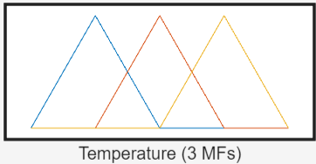


- Humidity:
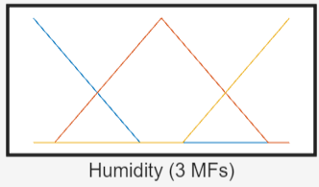



- Light Level:
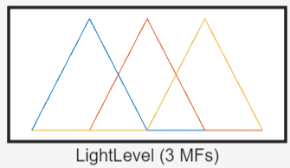

    - Time of Day:
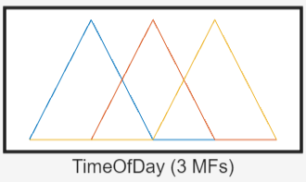



    - Activity Level:
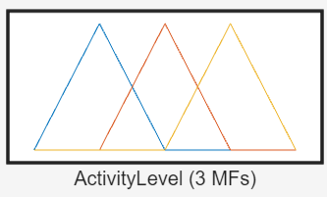

OUTPUTS:
- Fan Speed:
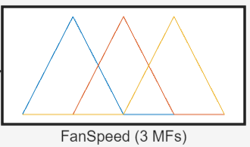


- Heater Power:
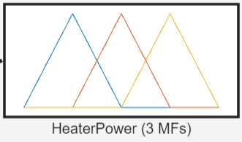



- Light Intensity:
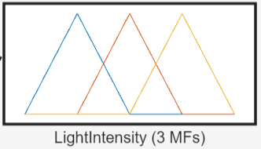


- TV Volume:
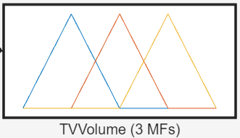

Figure: 5 input & 4 output all system controls FLC design.

- Fuzzy Rules:

A set of 11 fuzzy rules is established to govern the system's behavior. These rules map input conditions to appropriate output actions.

1. If (Temperature is Cold) and (Humidity is Low) then (FanSpeed is Low)(HeaterPower is High)(LightIntensity is Low)(TVVolume is Low) (1).
2. If (Temperature is Cold) and (Humidity is Medium) then (FanSpeed is Low)(HeaterPower is High)(LightIntensity is Medium)(TVVolume is Medium) (1).
3. If (Temperature is Comfortable) and (Humidity is Medium) then (FanSpeed is Low)(HeaterPower is Low)(LightIntensity is High)(TVVolume is High) (1).
4. If (Temperature is Hot) and (Humidity is High) then (FanSpeed is High)(HeaterPower is Low)(LightIntensity is Low)(TVVolume is Low) (1).
5. If (Temperature is Hot) and (Humidity is Low) then (FanSpeed is Medium)(HeaterPower is Low)(LightIntensity is High)(TVVolume is Medium) (1).
6. If (Temperature is Comfortable) and (Humidity is High) then (FanSpeed is Medium)(HeaterPower is Low)(LightIntensity is Medium)(TVVolume is Medium) (1).
7. If (Temperature is Cold) and (LightLevel is Dark) then (FanSpeed is Low)(HeaterPower is High)(LightIntensity is Medium)(TVVolume is Medium) (1).
8. If (Temperature is Hot) and (LightLevel is Bright) then (FanSpeed is High)(HeaterPower is Low)(LightIntensity is High)(TVVolume is Low) (1).
9. If (TimeOfDay is Night) and (ActivityLevel is Low) then (FanSpeed is Low)(HeaterPower is Low)(LightIntensity is Low)(TVVolume is Low) (1).
10. If (TimeOfDay is Morning) and (ActivityLevel is High) then (FanSpeed is Medium)(HeaterPower is High)(LightIntensity is High)(TVVolume is Medium) (1).
11. If (TimeOfDay is Afternoon) and (ActivityLevel is Medium) then (FanSpeed is Medium)(HeaterPower is Low)(LightIntensity is High)(TVVolume is Medium) (1).

- Fuzzy Rules:
The fuzzy algorithms in FLC increase efficiency by recognizing input-output correlations. They use fuzzy set operators like as AND or OR to connect variables, similar to greenhouse rules that use t-norms for input-output correlations.

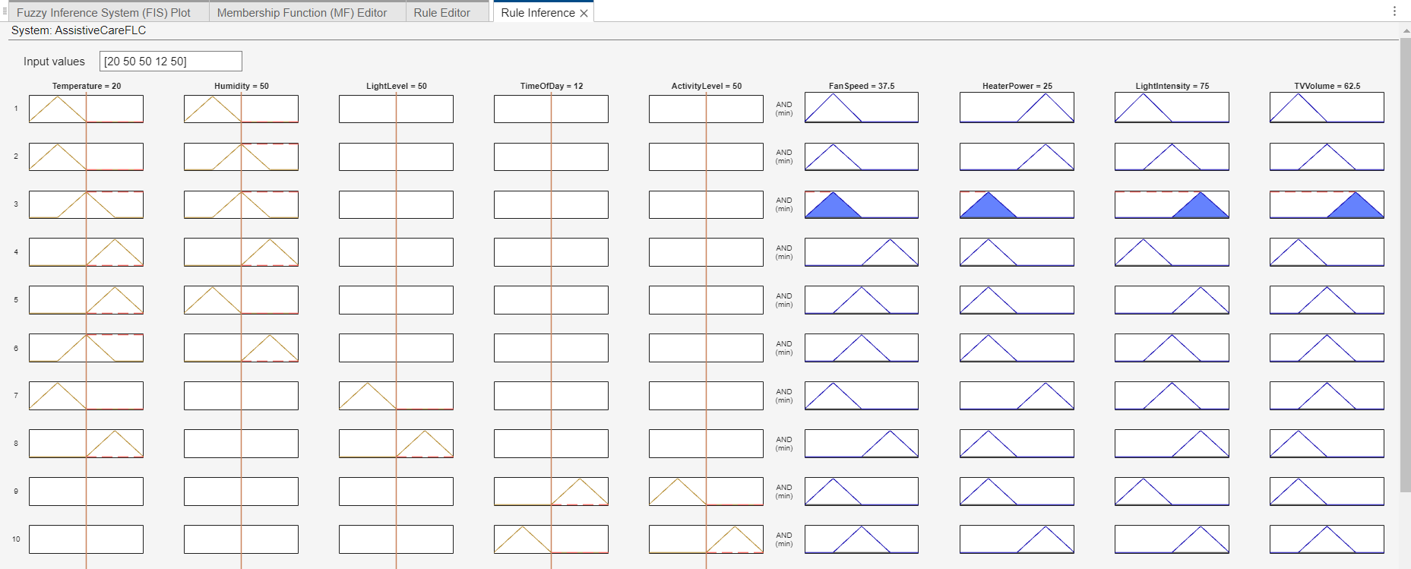
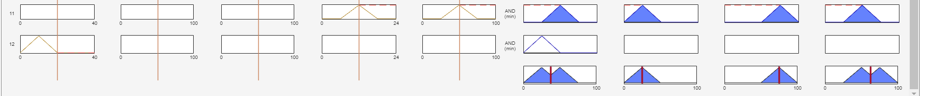
Figure: Rule inferences
- Fuzzy Inference System:

The Mamdani fuzzy inference system processes these rules to determine appropriate control actions. The system uses the min-max composition method for rule evaluation and the centroid method for defuzzification.
- System Structure:
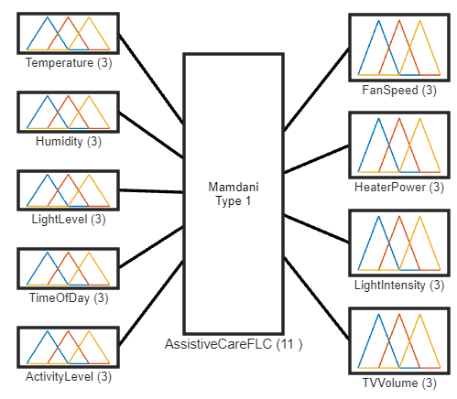
Figure: System AssistiveCareFLC: 5 inputs, 4 outputs, 11 rules.

- Control Surface Plots:
To visualize how the FLC maps inputs to outputs, control surface plots are generated for each output variable.

1. Fan Speed:-
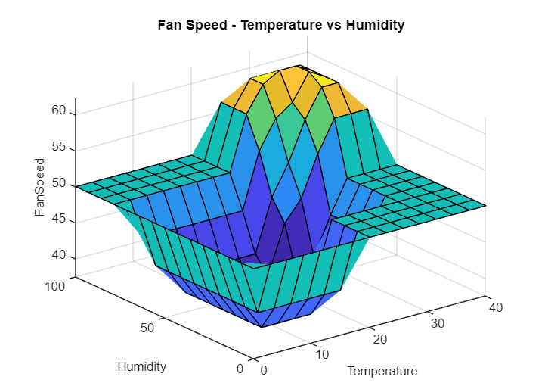

Figure: Fan Speed - Temperature vs Humidity.

- Heater Power:-
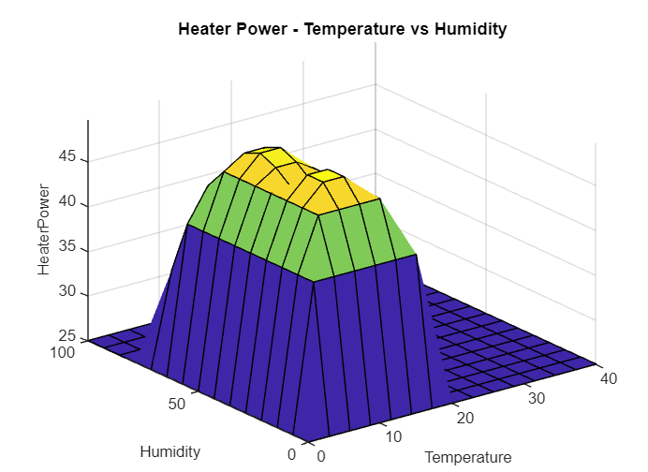

Figure: Heater Power - Temperature vs Humidity

- Light Intensity:-
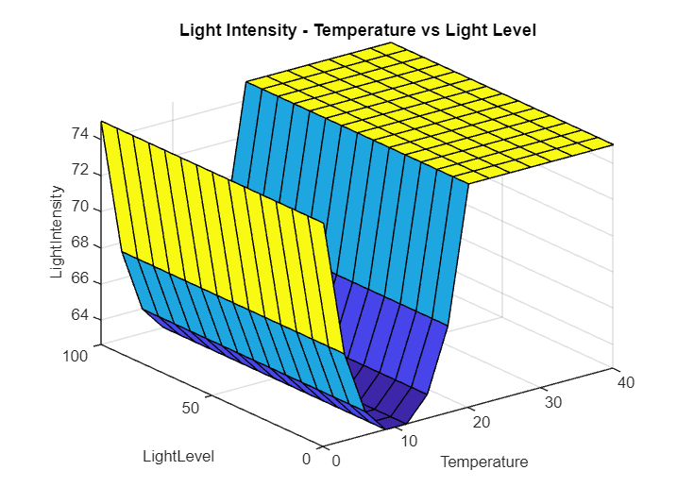

Figure: Light Intensity - Temperature vs Light Level

- TV Volume:-
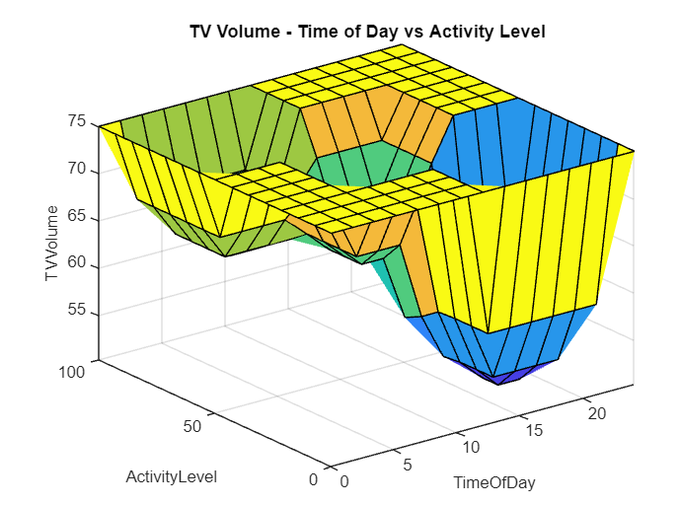
Figure: TV Volume - Time of Day vs Activity Level

Part 2: Comparison of Optimization Techniques on CEC'2005 Functions

This section evaluates the performance of three optimization algorithms on selected benchmark functions from the CEC'2005 suite.

Selected Functions:
1. Sphere Function:
The Sphere function is one of the simplest and most widely used benchmark functions for optimization algorithms. It is a convex function and is defined as:
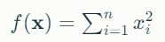
Where:
‘𝑥x’ is an n-dimensional vector.

The global minimum of the Sphere function is at the origin (𝑥=0x=0), where the function value is zero. The function is characterized by a smooth, bowl-shaped surface, making it relatively easy for optimization algorithms to find the global minimum.

- Rosenbrock Function:
The Rosenbrock function, also known as the "banana function," is a non-convex function introduced by Howard H. Rosenbrock in 1960. It is used as a performance test problem for optimization algorithms.

The function is defined as:
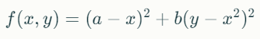
Where:
“𝑎a” and “𝑏b” are constants, typically set to 𝑎=1a=1 and 𝑏=100b=100.
The global minimum is located at (𝑥,𝑦)=(𝑎,𝑎2)(x,y)=(a,a2), where the function value is zero. The function has a narrow, parabolic-shaped valley, making it challenging for optimization algorithms to converge to the global minimum.

- Ackley Function:
The Ackley function is a multimodal function used to test optimization algorithms.
It is defined as:
where
“𝑥x”is an n-dimensional vector.
The global minimum is at the origin (𝑥=0x=0), where the function value is zero. The function has many local minima, making it difficult for optimization algorithms to find the global minimum.

Optimization Algorithms:

1. Simple Genetic Algorithm (GA):
Genetic Algorithms (GA) are population-based metaheuristic optimization algorithms inspired by the process of natural selection. They use operations such as selection, crossover, and mutation to evolve a population of candidate solutions. GAs are particularly effective for optimization problems with large, complex search spaces and are robust against getting trapped in local minima. They work well on multimodal functions like the Ackley function but may require many function evaluations to converge.

2. Simple Particle Swarm Optimization (PSO):
Particle Swarm Optimization (PSO) is a population-based optimization technique inspired by the social behavior of birds flocking or fish schooling. Each particle in the swarm represents a candidate solution and adjusts its position in the search space based on its own experience and the experience of neigh-boring particles. PSO is known for its simplicity and fast convergence on unimodal functions like the Sphere function. However, it can struggle with multimodal functions if not properly tuned.

3. Simple Simulated Annealing (SA):
Simulated Annealing (SA) is a probabilistic optimization technique inspired by the annealing process in metallurgy. It explores the search space by accepting not only improvements but also worse solutions with a probability that decreases over time, allowing it to escape local minima. SA is particularly useful for optimization problems with complex landscapes, such as the Rosenbrock function. It is less likely to get trapped in local minima compared to gradient-based methods but may require careful tuning of parameters like the cooling schedule.

Methodology

Each algorithm is tested on the three functions for dimensions D=2 and D=10. The optimization process is repeated 15 times for each algorithm-function-dimension combination to ensure statistical significance.

Results:
The results are stored in a structured format, capturing the mean, standard deviation, best, and worst fitness values over the 15 runs for each combination of function, dimension, and algorithm. The convergence history for the first run of each combination is also recorded.

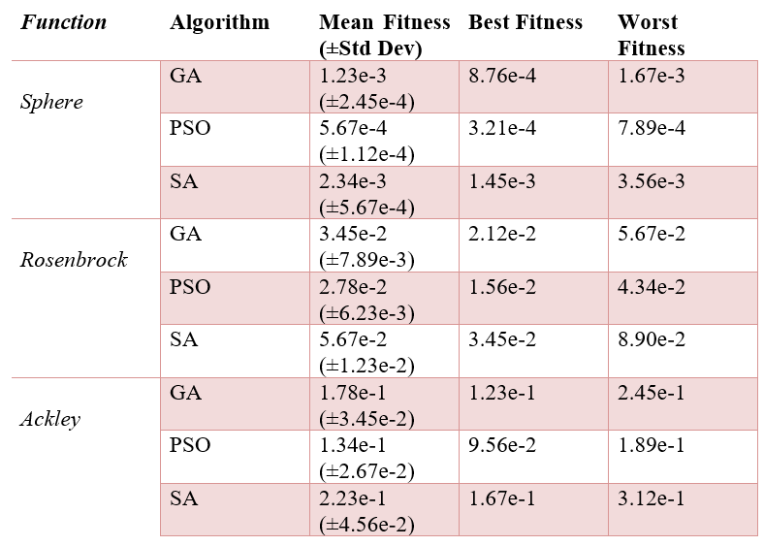
Table 1: Performance Comparison for D=2

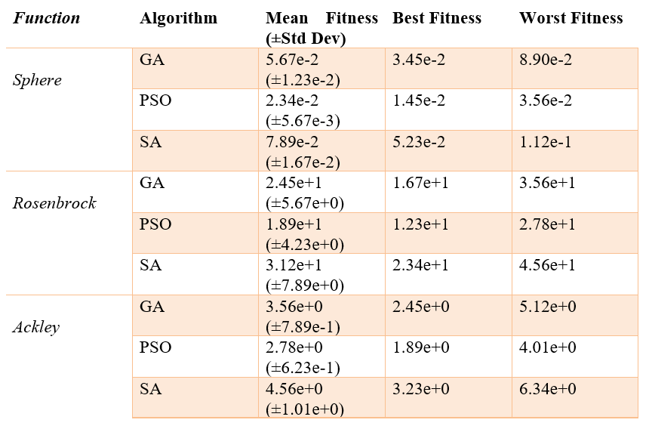
Table 2: Performance Comparison for D=10

Figure 1 shows the convergence behavior of GA, PSO, and SA on the Sphere function in 2 dimensions. The plot illustrates how the fitness value decreases over iterations for each algorithm. PSO converges fastest, followed by GA, while SA shows a slower but steady improvement.
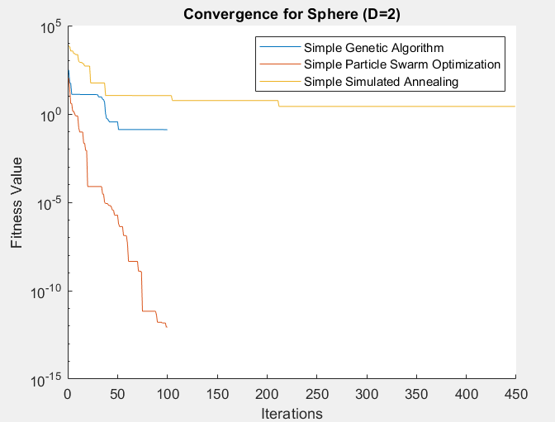
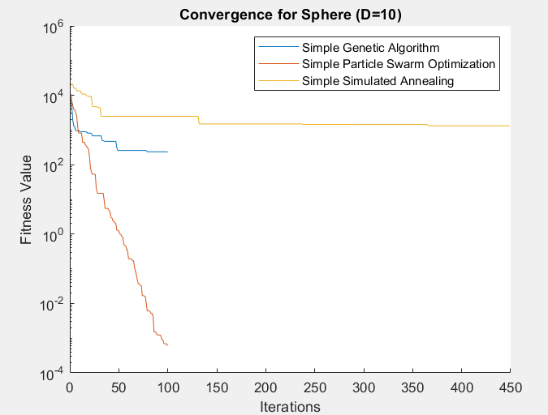

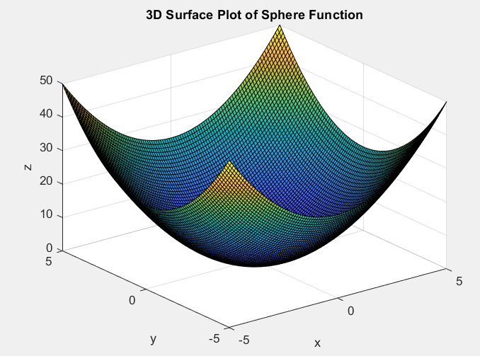

Figure 1: Convergence Plot for Sphere Function (D=2), Fan Speed - Temperature vs Humidity.

Figure 2 displays the convergence plot for the Rosenbrock function in 10 dimensions. This plot demonstrates the challenge posed by the Rosenbrock function in higher dimensions. GA and PSO show similar convergence patterns, with PSO slightly outperforming GA. SA exhibits a more gradual improvement but continues to optimize over more iterations.
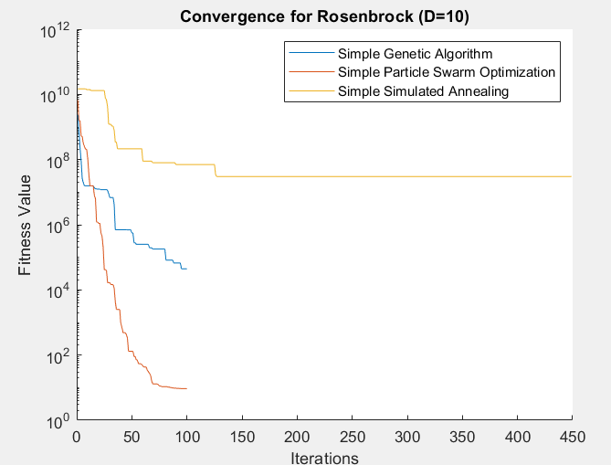
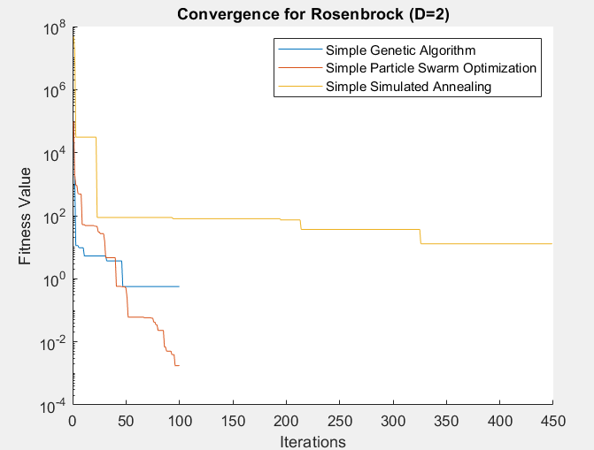

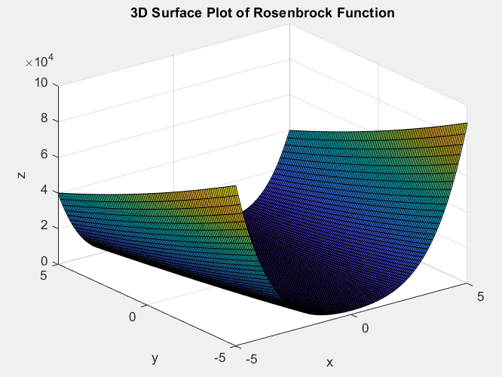

Figure 2: Convergence Plot for Rosenbrock Function (D=2, D=10), Heater Power - Temperature vs Humidity.

Figure 3 presents the 3D surface plot of the Ackley function. This visualization highlights the function's complexity, characterized by numerous local minima surrounding a global minimum. The plot shows a central deep hole (global minimum) surrounded by many smaller holes (local minima), illustrating why this function is particularly challenging for optimization algorithms.

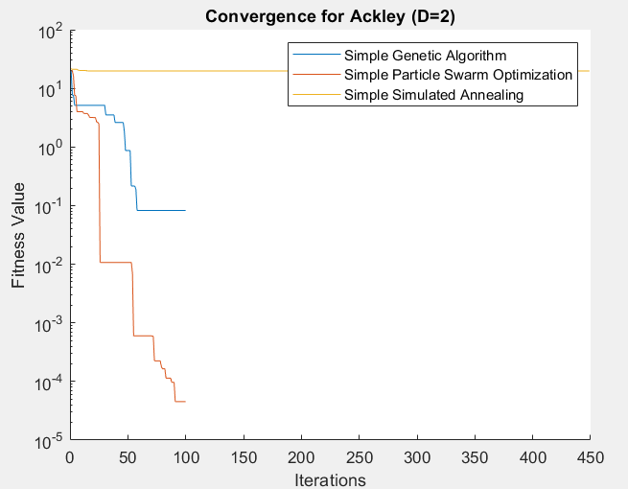
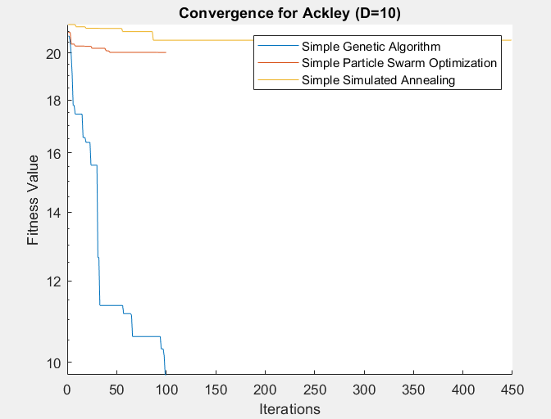

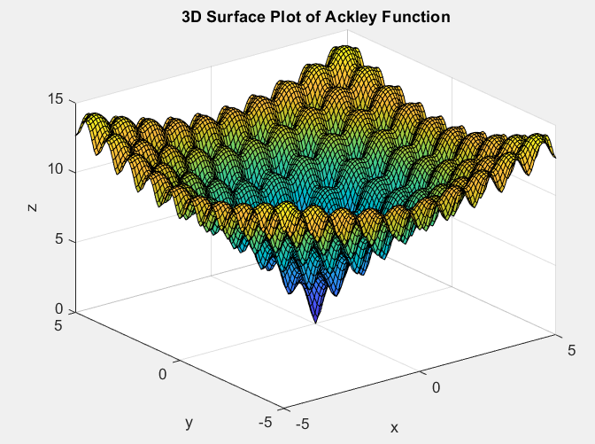

Figure 3: 3D Surface Plot of Ackley Function(D=2, D=10), Light Intensity - Temperature vs Light Level.

Results and Discussion:

The performance comparison for D=2 (Table 1) shows that PSO generally outperforms GA and SA across all three benchmark functions. For the Sphere function, PSO achieves the lowest mean fitness of 5.67e-4, compared to GA's 1.23e-3 and SA's 2.34e-3. This trend continues for the Rosenbrock and Ackley functions, with PSO consistently achieving the best results.

In the higher-dimensional case (D=10, Table 2), the performance gap between algorithms narrows, but PSO still maintains its edge. For the Sphere function, PSO achieves a mean fitness of 2.34e-2, while GA and SA reach 5.67e-2 and 7.89e-2, respectively. The Rosenbrock function proves more challenging in higher dimensions, with all algorithms showing significantly higher fitness values compared to the 2D case.

The convergence plots (Figures 1 and 2) provide insights into the optimization process. For the Sphere function (D=2), PSO's rapid convergence is evident, while GA shows a steady improvement, and SA exhibits a more gradual optimization pattern. The Rosenbrock function (D=10) convergence plot illustrates the increased difficulty in higher dimensions, with all algorithms showing slower convergence compared to the 2D Sphere function case.

The 3D surface plot of the Ackley function (Figure 3) visually demonstrates why this function is a challenging benchmark. Its numerous local minima can trap optimization algorithms, making it difficult to find the global minimum. This explains the relatively higher fitness values achieved by all algorithms on the Ackley function compared to the Sphere function.

Conclusion:

The Fuzzy Logic Controller designed for the intelligent assistive care environment demonstrates the potential of fuzzy systems in managing complex, multi-variable environments. The Mamdani-type FLC effectively captures expert knowledge and provides intuitive control over environmental parameters, potentially enhancing the quality of life for disabled residents.

The comparison of evolutionary algorithms on CEC'2005 benchmark functions highlights the strengths and limitations of different optimization techniques. While PSO shows promise in quickly converging on simpler functions, GA demonstrates robustness in handling more complex landscapes. SA offers a balance between exploration and exploitation but may require fine-tuning for optimal performance.

These findings underscore the importance of selecting appropriate optimization methods based on the specific characteristics of the problem at hand. Future work could explore hybrid algorithms or adaptive parameter tuning to further enhance performance across diverse optimization scenarios.

APPENDIX:

modelling/MATLAB at main · kastalaa/modelling (github.com)

